IDEATION PHASE

Brainstorm & Idea Prioritization

**PROJECT NAME :** Retail Store Stock Inventory Analytics

**TEAM ID :** *PNT2022TMID38117*

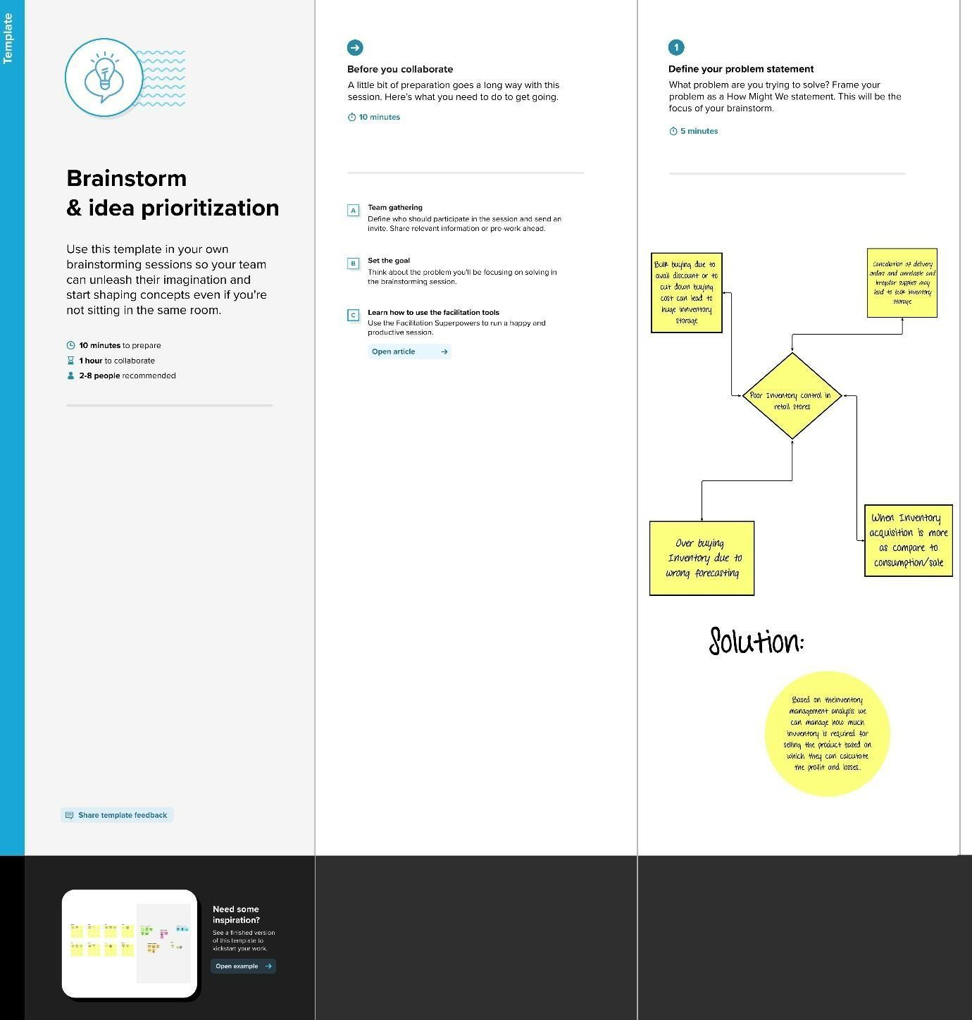Step 1:

Step 2:

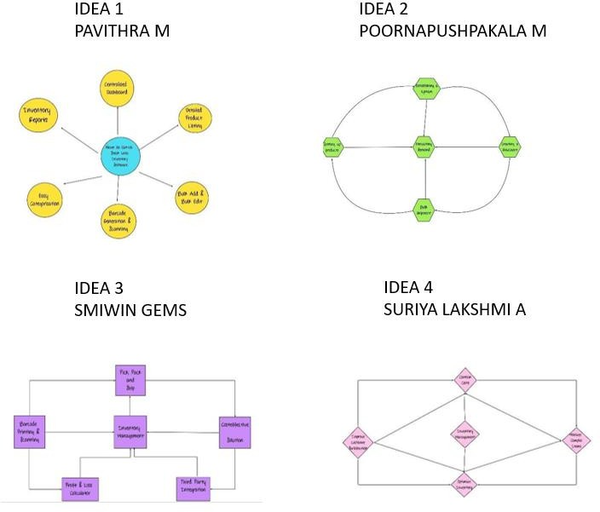

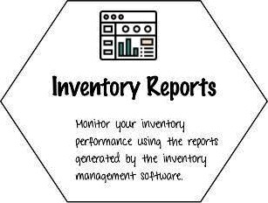

Easy catz9arization

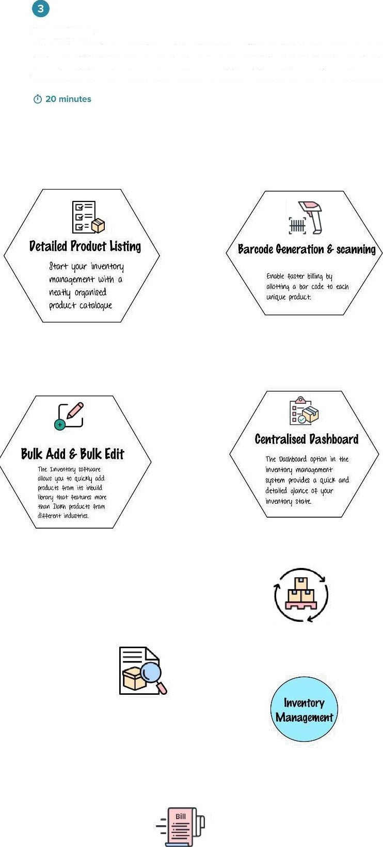

Group ideas

Take turns sharing your ideas while clustering similar or related notes as you go. In the last 10 minutes, give each cluster a sentence-like label. If a cluster is bigger than six sticky notes, try and see if you and break it up into smaller sub-groups.







Step 3:

